Lesson Topic: Understanding Sexual Orientation & Gender
Objectives:
- Explain the meanings of gender, gender identity, and sexual orientation.
- Describe the three components of sexual orientation (orientation, behavior and identity).
- Define different gender expectations in our culture.
- Identify where they receive messages about gender expectations.
Activities:
Brainstorm the meanings of gender and sexual orientation and how they differ.
Sexual orientation: myths and facts
Reflect on received messages regarding how people assigned “female” and “male” genders should act.
Lesson Preamble:
“Family, religious, and cultural traditions and beliefs shape who we are as individuals today. As individuals, we have different perceptions and understanding of our own sexuality and that of others. Some traditions believe in one definition of sexual orientation, such as heterosexuality, and one definition of gender identity, such as cisgender, while other traditions and beliefs recognize diverse orientations, identities and expressions. These disagreements and differences are common in a diverse community, but they cannot be used as the basis to be hurtful, discriminatory, or to exclude any group. It is important to understand our own values and beliefs and how they related to who we are and who others are.
This curriculum and resulting class discussions are intended to be respectful and inclusive of traditions that reflect many perspectives and allow all students to see themselves and understand their own health and sexuality.”

Lesson: Part 1
Setting the ground rules about language:
Go to the flipchart sheet with “Use with Caution” written on it. Ask the class, “When you see a yellow sign out in the world-like by a construction site- what does that tend to mean?” Probe for “caution.” Say, “A lot of times people are taught certain language around sexual orientation that is offensive or wrong-and other times, there are words that are sometimes okay and sometimes not. So, there are times we must use caution before using them. Take down the bottom half of the chart and explain to the class that as we go along, it’s possible that some of these words or phrases will come up. If I hear one or use one, which is likely to happen as we go through the lesson, I will write it on our chart.
1. Start the PowerPoint
- Slide 2: What is Sexual Orientation? Brainstorm responses
  - Possible responses:
    - Who you like
    - Who you’re attracted to
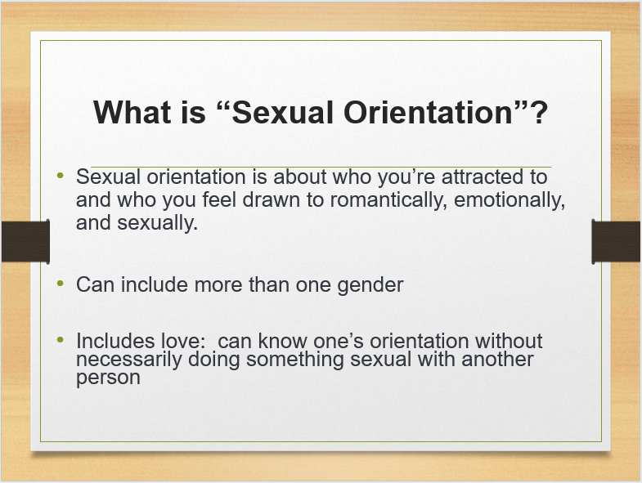
- Slide 3: What are some names we have for sexual orientation categories?

  - For example, if someone is attracted only to people of a different sex, what might that person call themselves?” (Probe for “heterosexual;” chances are, you will hear “straight*.” Be sure to say, “Straight – or heterosexual” as you put “straight” up on the Use Caution language list). Ask for other ideas, which may include
- Straight*
- Gay
- Lesbian
- Homosexual*
- Bi or Bisexual
- Queer*
- Pansexual
- Asexual
Once the list is up, click on PPT to show each term.

- Slide 4-8: What does each term mean?
- Heterosexual – someone who is only attracted to people of a different gender

- Lesbian or gay – someone who is only attracted to someone of their same gender

- Bisexual – someone who may be attracted to people of their own gender AND to people of a different gender.

*Note to the Teacher: If you choose to describe “pansexual,” or if a student has used that term, this would be the time to explain what it means – that bisexual technically means “two,” and pansexual means “many.” So people who are attracted to more than two genders – including transgender individuals – may use the term “pansexual” rather than “bisexual.”

- Queer* – students often struggle with this one. It can be used in a number of ways: someone may feel like the other categories are too restrictive and don’t describe them accurately. Someone may wish to take back the negative meaning of the word and use it as a positive way of describing who they are.

- Asexual – If this term comes up, you would define it as someone who does not have feelings of sexual attraction. An asexual person can still fall in love with and be in relationships with other people, but these relationships do not include a sexual relationship.

* Note to the Teacher: Some students will add in “transgender,” mostly because they have seen the acronym, “LGBT.” Be sure to tell them that being transgender is not about sexual orientation or who we are attracted to, but it is about how we understand our gender.
For example someone may be male, or female, or transgender – and still have a sexual orientation.

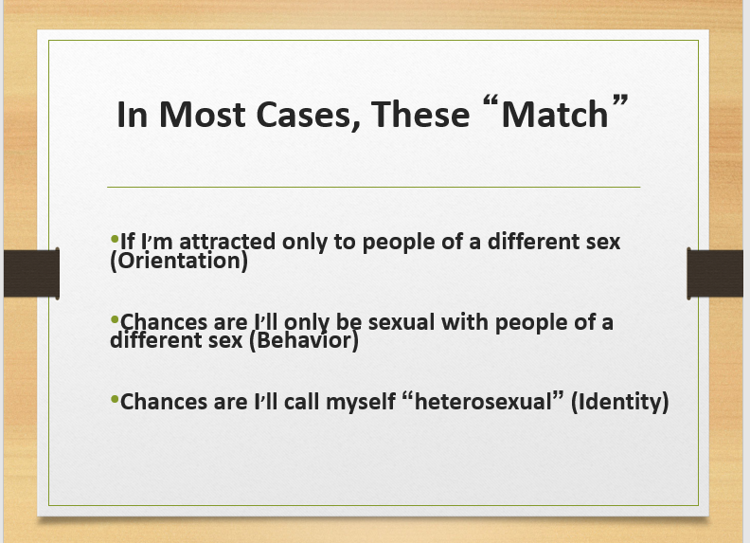
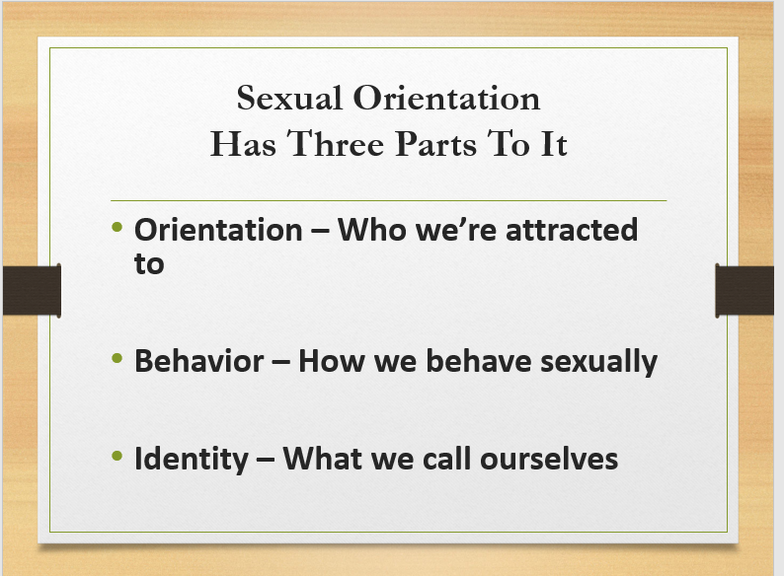
- Slides 9-11: Explain the concepts of Orientation, Behavior, and Identify.
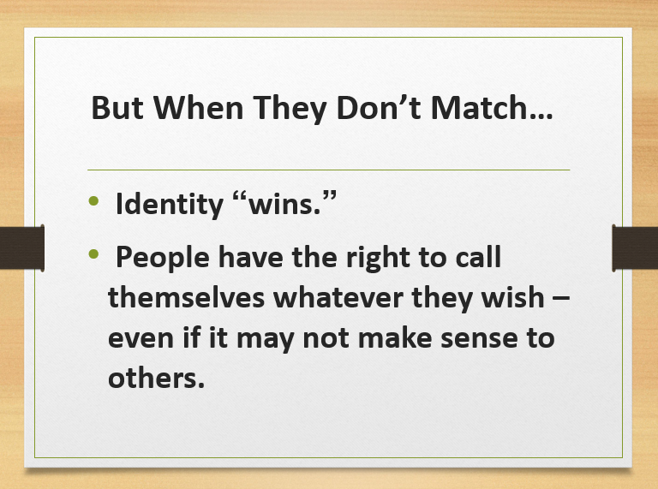

Activity: Sexual Orientation-Myths/Facts
- There’s a lot of talk in the media about people of all different sexual orientations. Some is true and a lot is incorrect information.
  - Pass out Myths and Facts (give students about 5 minutes to complete, then have them partner up and compare answers. Discuss student responses as a whole group.
  - Using the Teachers Myths and Facts Guide, go through each question and ask students to volunteer their answers and reasoning’s. Have students make any corrections as answers are reviewed.
INSTRUCTIONS: Decide whether each of the statements is a myth or a fact, and circle the corresponding response.

- You can tell whether someone is heterosexual, lesbian or gay, or bisexual by the way they look or act.

MYTH FACT

- Most know what their sexual orientation is by the time they are 13
MYTH FACT

- The way parents raise their children determines whether a child is heterosexual, lesbian or gay, or bisexual.

MYTH FACT

- If you try really hard, you can change your sexual orientation – regardless of whether you are heterosexual, lesbian or gay, or bisexual.

MYTH FACT

- In a same-sex relationship, one person plays a “male” role, and the other plays a “female” role.

MYTH FACT

- The majority of people in the world with HIV or AIDS are gay men.

MYTH FACT

- With the 2015 US Supreme Court Decision on marriage equality, LGB people now have all the same rights as heterosexual people.

MYTH FACT

Myth vs. Fact Responses:
- You can tell whether someone is heterosexual, lesbian or gay, or bisexual by the way they look or act.

MYTH

The answer here is really, “not necessarily.” Sometimes, a person will act in a way that fulfills stereotypes about a heterosexual, lesbian or gay, or bisexual person. But people act, speak, and dress in all different ways, regardless of their sexual orientation. They have
many different kinds of families, jobs, and interests. So while someone may guess correctly that a person is a particular orientation, they could guess the same about someone with similar characteristics and be completely wrong. When in doubt, ask – or, better yet, wait for them to share with you who they are. We all have a right to decide when we want to share personal information about ourselves with others.

- Most people know what their sexual orientation is by the time they are 13 years old.

MYTH

It’s really different for everyone. Some people know from a very young age. Many children who do not end up identifying as heterosexual say they had a sense of being “different” growing up, but they didn’t necessarily have the language to articulate it. Others are sure they are one orientation, and then come to discover later that they are not. Still, others know very well what orientation they are, but act in ways that will enable them to conceal it. This is particularly risky when it comes to safer sexual behaviors; if someone, for example, were to get pregnant or get someone pregnant in order to hide that they aren’t heterosexual.

- The way parents raise their children determines whether a child is heterosexual, lesbian or gay, or bisexual.

MYTH

The vast majority of lesbian, gay, bisexual, heterosexual and other people were raised by heterosexual parents or caregivers. Similarly, there are lesbian, gay, bisexual, and other parents and caregivers who raise heterosexual children. A parent or caregiver does not determine a child’s orientation by how they behave with their child, by their own orientation, or by the activities their children do at home or out in the world. (For example, playing with dolls does not “make” a boy gay – he may be and he may not be, but his orientation was already determined before he started playing with those dolls.)

- If you try really hard, you can change your sexual orientation – regardless of whether you are heterosexual, lesbian or gay, or bisexual.

MYTH

Nope. You can change your BEHAVIORS, you can change your IDENTITY – but you can’t
change your ORIENTATION, or how you feel. Feelings of attraction are discovered, not chosen. It isn’t something a person can turn on and off like a light switch. We don’t choose who we are attracted to. Now, sometimes we can discover new feelings of attraction – for example, always being attracted to one gender, and then finding someone or others of a different gender attractive later in life. That is different from sitting down and trying to change the way you feel.
Conversion therapies do not work and can end up doing real psychological and emotional harm. In 2017, the Nevada legislature passed SB 201. The purpose of SB201 is to protect the well-being of children who are under 18 years of age by prohibiting such licensed health care professionals from providing children with conversion therapies. SB 201 defines Conversion Therapy as, any practice or treatment that seeks to change the sexual orientation or gender identity of a person, including, without limitation, a practice or treatment that seeks to change behaviors or gender expressions or to eliminate or reduce sexual or romantic attractions or feelings toward persons of the same gender.”

- In a same-sex relationship, one person plays a “male” or “butch” role, and the other plays a “female” or “femme” role.

MYTH

Like in question number one, this is also a “not necessarily” answer. Most societies are stuck in a binary gender perspective – meaning that there needs to be a man figure and a woman figure in a relationship for it to work. As a result, people will look to a stereotypically “masculine” person to fulfill the “male” role in a same-gender relationship, and a “feminine” person to fulfill the “female” role. Now, in some relationships, people do express characteristics that may be judged by some to be either “masculine” or “feminine” – but gender doesn’t necessarily determine this. For example, in a different-gender relationship, a female partner may support the family financially while her male partner is a stay-at-home
dad and raises the children. In a lesbian relationship, one partner may make more money and the other may stay home and raise children. It is circumstance that causes these decisions to be made, not the desire to “be like a man” or “be like a woman”.

- The majority of people in the world with HIV or AIDS are gay men.

MYTH

Approximately 37 million people around the world are living with HIV or AIDS. Women and children make up about half of those cases, and men make up the rest. The vast majority of people living with HIV around the world are women who contracted HIV from a male partner. Keep in mind, however, many people have same-sex behaviors but don’t identify as gay or lesbian.

- With the 2015 US Supreme Court Decision on marriage equality, LGB people now have all the same rights as heterosexual people.

MYTH

The US Supreme Court decision granting the right for same-sex couples to marry throughout the US only applies to that. In many states, LGB people can still be discriminated against in the workplace, in housing and in medical settings. It was a huge decision relating to equal rights, but there is much work left to do to eliminate prejudice and stigma for LGB people.

Go Back to Flipchart:
- Go over any terms that were added to the chart. Ask if any have been left off.
  - If any derogatory terms have been given, explain to students that these are very derogatory and not to be used… (Could put up a red stop sign or a red light on a traffic signal).
Lesson: Part 2:
Slide 12:
  - Ask, “What does gender mean?” In most cases, people will say, “it’s whether you’re a boy or a girl.” After a few responses, ask, “How does someone determine whether you’re a boy or girl?” There will likely be a range of responses, but most commonly they will get at “it’s how you’re born.” Ask, “When you’re born, how do they know what your gender is?” Probe for “by looking at the baby’s genitals.”
  - Explain that there’s a slight difference here – that when you look at the baby’s genitals, all you’re seeing is their external body parts.
    - Based on what we see, we assign a name to describe that baby – we say, “it’s a boy” or “it’s a girl.”
      - This is called a person’s biological sex (write the phrase “biological sex” up on the board to the left of the word gender).
        - “Intersex” people who are born with external genitals that don’t match their internal organs. For example, someone who has a vulva but no uterus.
- Look in the mirror and see your body, what you see in the mirror – what we just discussed – is part of your biological sex.
  - Gender identity is how you see yourself based on those body parts.
Slides 13-14:
    - Cisgender: a person’s gender (how they feel on the inside) identity corresponds to the person’s biological sex assigned at birth.
    - Transgender: a person’s gender identity (how they feel on the inside) that does not correspond to the biological sex assigned at birth.
Slide 7:
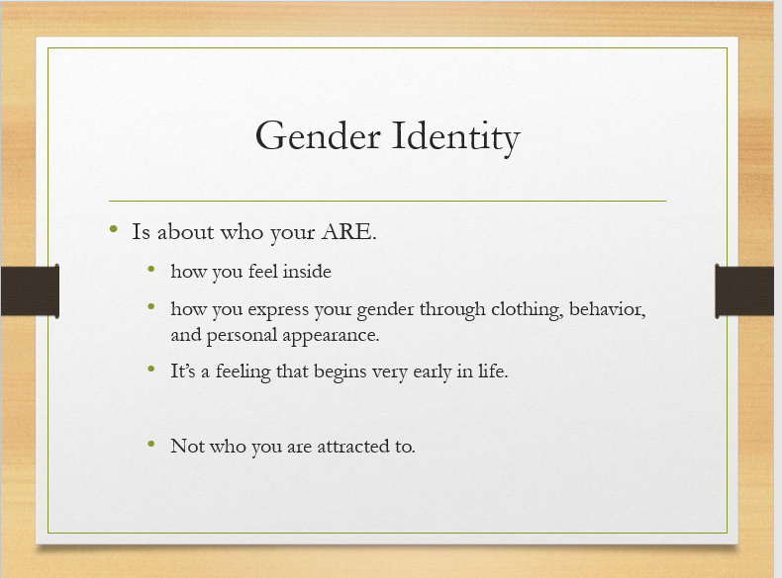

Activity: Scripts
Gender scripts are how people are expected to behave based on their biological sex.
- Have students work in small group
- Pass out Gender Scripts activity sheet
  - Have students list gender scripts heard about people of a different gender from your own. For right now, we’re just going to talk about boys and girls.
  - Have students share their responses with the group and write on board.
- Ask students
  - What do they notice about the list
  - How did you know that these were the gender scripts growing up
  - From where/whom have you been receiving these scripts
- So far we’ve been talking about people who are assigned either male or female at birth and what they see on the outside (genitals) and what they feel on the inside, match.
- Sometimes, however, the body parts are different from how a person feels on the inside. That person may call themselves ‘transgender.’ How might someone who identifies as transgender react to these scripts?”
  - Have students discuss
Gender Scripts Activity:
Directions:
- From the time we are born, we receive messages about the way we are supposed to act, dress and speak based on the sex we are assigned at birth-just like we were provided a script and asked to follow it through our lives.
- In the space provided, please give examples of some of the messages you or people close to you have received about how we are supposed to behave based on whether a person was assigned male or female at birth.
ASSIGNED FEMALE ASSIGNED MALE

Closing: Probe for questions or any clarifications that need to be addressed.

